Medicare
Architecture and Design Analysis Report
Name: Hitanshu Bhatt
Student ID: 000367185
Cancer Detection Capstone II Project
Prepared from the submitted project repository and UI assets
Project type | Full-stack medical web application with image-classification ML component
Core architecture | FastAPI backend + static frontend + MySQL + PyTorch model
Primary dataset | Lung histopathology image folders with 4 output classes
Report focus | Architecture selection, interface contracts, stack justification and design patterns

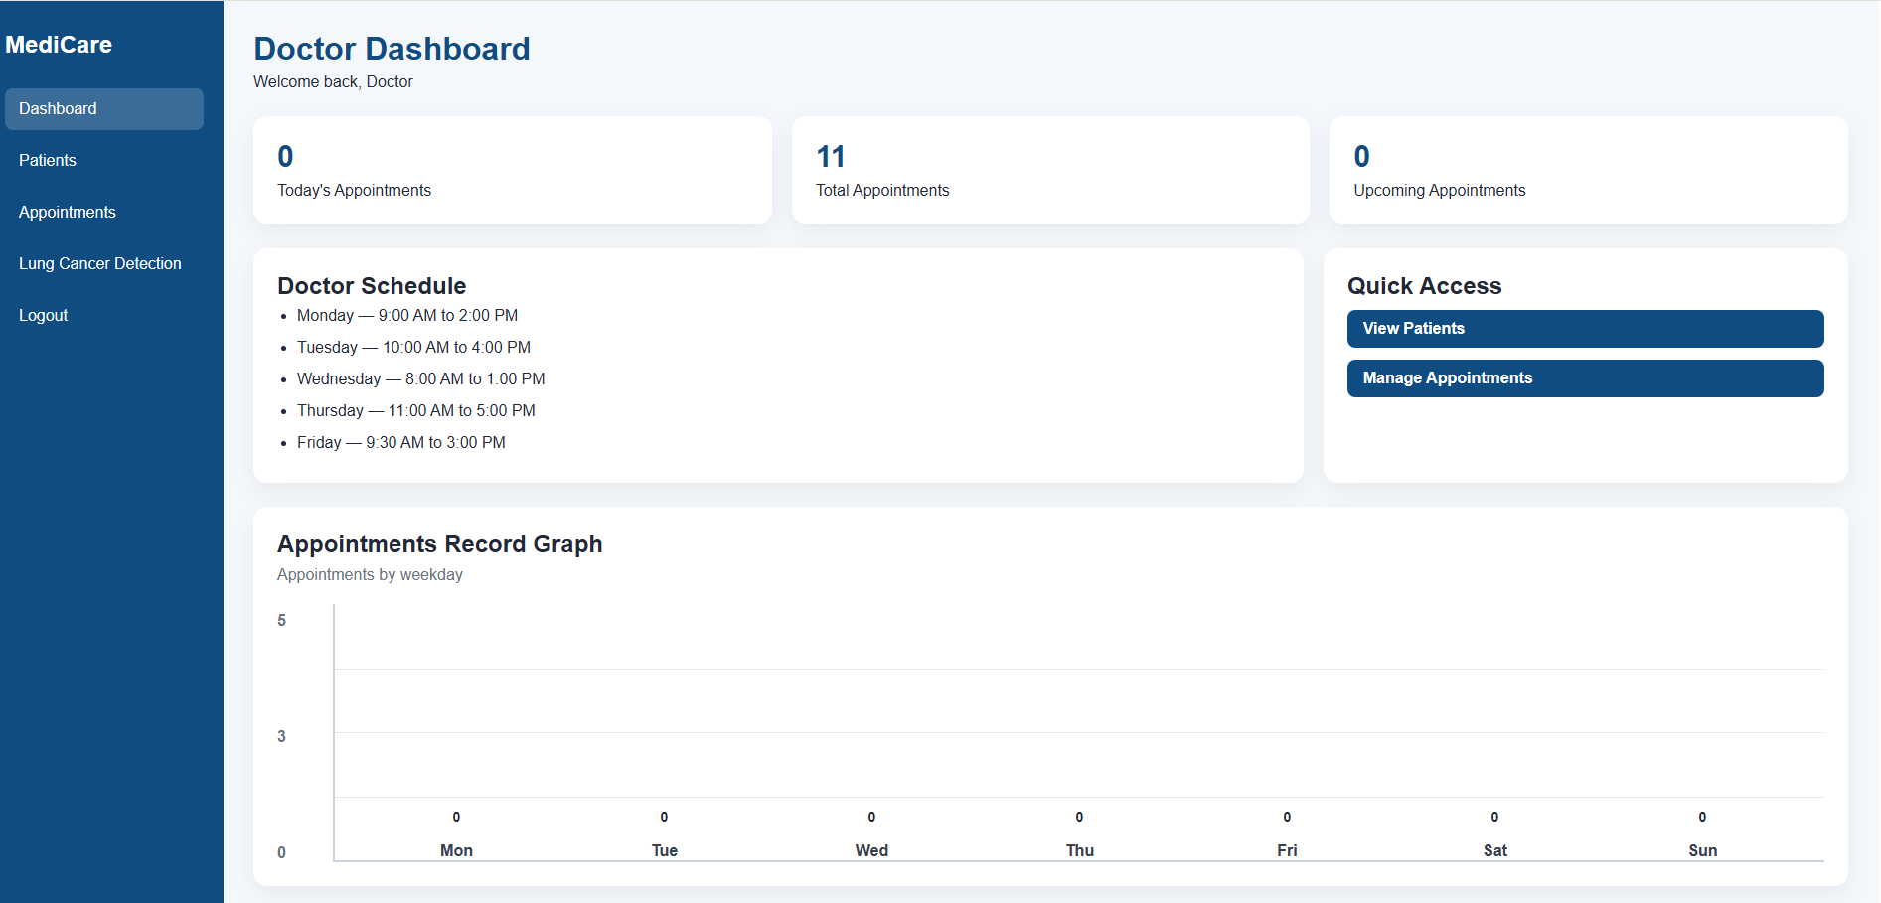
Figure 1. Doctor dashboard interface used as the main operational view for clinicians.

1. Executive Summary
This report evaluates the submitted LungVision Pro project as a deployable capstone system rather than only as a machine-learning notebook. The repository contains a browser-based doctor workflow, a FastAPI backend, MySQL persistence, and an EfficientNet-B0 image classifier for four-way lung-cancer categorization. The selected architecture is best described as a layered monolith: presentation pages call one REST API, the API coordinates both database operations and inference services, and a single relational database stores operational records.
The strongest architectural decision in the project is the choice to keep the first release simple. For a student capstone with one primary developer, a monolithic deployment minimizes operational overhead, keeps debugging manageable, and allows fast integration across doctor registration, appointments, patient data, and model inference. The main trade-off is that tighter coupling between frontend expectations and backend routes has already produced contract gaps that would need to be resolved before production use.
From the code inspection, the solution already demonstrates several good software-engineering habits: modular ML loading through dedicated service files, use of Pydantic request models, normalized image preprocessing, and a clear separation between training scripts and runtime inference. However, the implementation still requires contract completion and security hardening, especially around authentication, credential management, and endpoint consistency.
2. Evidence Collected from the Repository
Repository area | Observed files | Architectural implication
Frontend | HTML, CSS and JS pages for login, dashboard, patients, appointments, booking and detection | Confirms browser-based presentation layer with manual fetch integration
Backend | FastAPI main.py, database helper, prediction router, model loader and prediction service | Confirms API layer and modular ML inference path
Training | train.py, lung_model.py, test.py, saved .pth model | Confirms offline training workflow separated from deployed inference
Data assets | Datasets/train, validation and test folders; screenshots/ | Supports ML training and report visuals
Dataset folders indicate a 4-class image-classification problem with the following visible file counts in the supplied repository: training = 613 images, validation = 72 images, and test = 315 images. The training split is somewhat imbalanced, which makes the use of transfer learning on EfficientNet-B0 reasonable for achieving useful performance with limited data.
3. Architecture Selection and Trade-off Analysis
Three realistic architectural approaches fit this project: a layered monolith, a microservices design, and a strictly separated SPA-plus-API system using a heavier front-end framework. The implemented code most closely matches the layered monolith, and for this capstone that is the most defensible choice.
Approach | Fit for this project | Advantages | Disadvantages | Overall verdict
Layered monolith | High | Single deployment, fast debugging, low ops overhead, easier integration for one team | Can become tightly coupled; scaling all modules together; route drift can affect multiple pages | Best choice for capstone MVP
Microservices | Low to medium | Independent scaling of auth, booking and ML inference; stronger team parallelism | Too much complexity for student scope; needs service discovery, monitoring and container orchestration | Over-engineered for current scope
SPA + separate backend | Medium | Richer component reuse and stronger client-side state control | Adds framework learning cost; more build tooling; still needs the same backend contracts | Good future evolution, not necessary for first release
Why the layered monolith was the correct choice:
• Scalability needs are modest at capstone stage. Appointment volume and inference traffic can be handled on one backend process or a small number of replicated instances.
• Team size is effectively one developer, so a unified codebase reduces coordination cost and keeps change impact visible.
• Deployment is simpler. A FastAPI server, a MySQL instance and static pages are easier to demonstrate and maintain than multiple networked services.
• Feature coupling is naturally high because diagnosis, booking and patient context are used together in the same doctor workflow.
Trade-offs identified:
• The backend mixes database access styles: aiomysql is used in signup while mysql.connector is used elsewhere. This weakens architectural consistency.
• Several frontend pages call routes that are not present in the inspected main.py file, including /login, /patients, /register-patient and /add-appointment. This is a contract mismatch risk.
• The ML inference path is modular, but it still ships inside the same application process. Under heavy GPU/CPU load, diagnostic inference could affect operational API latency.
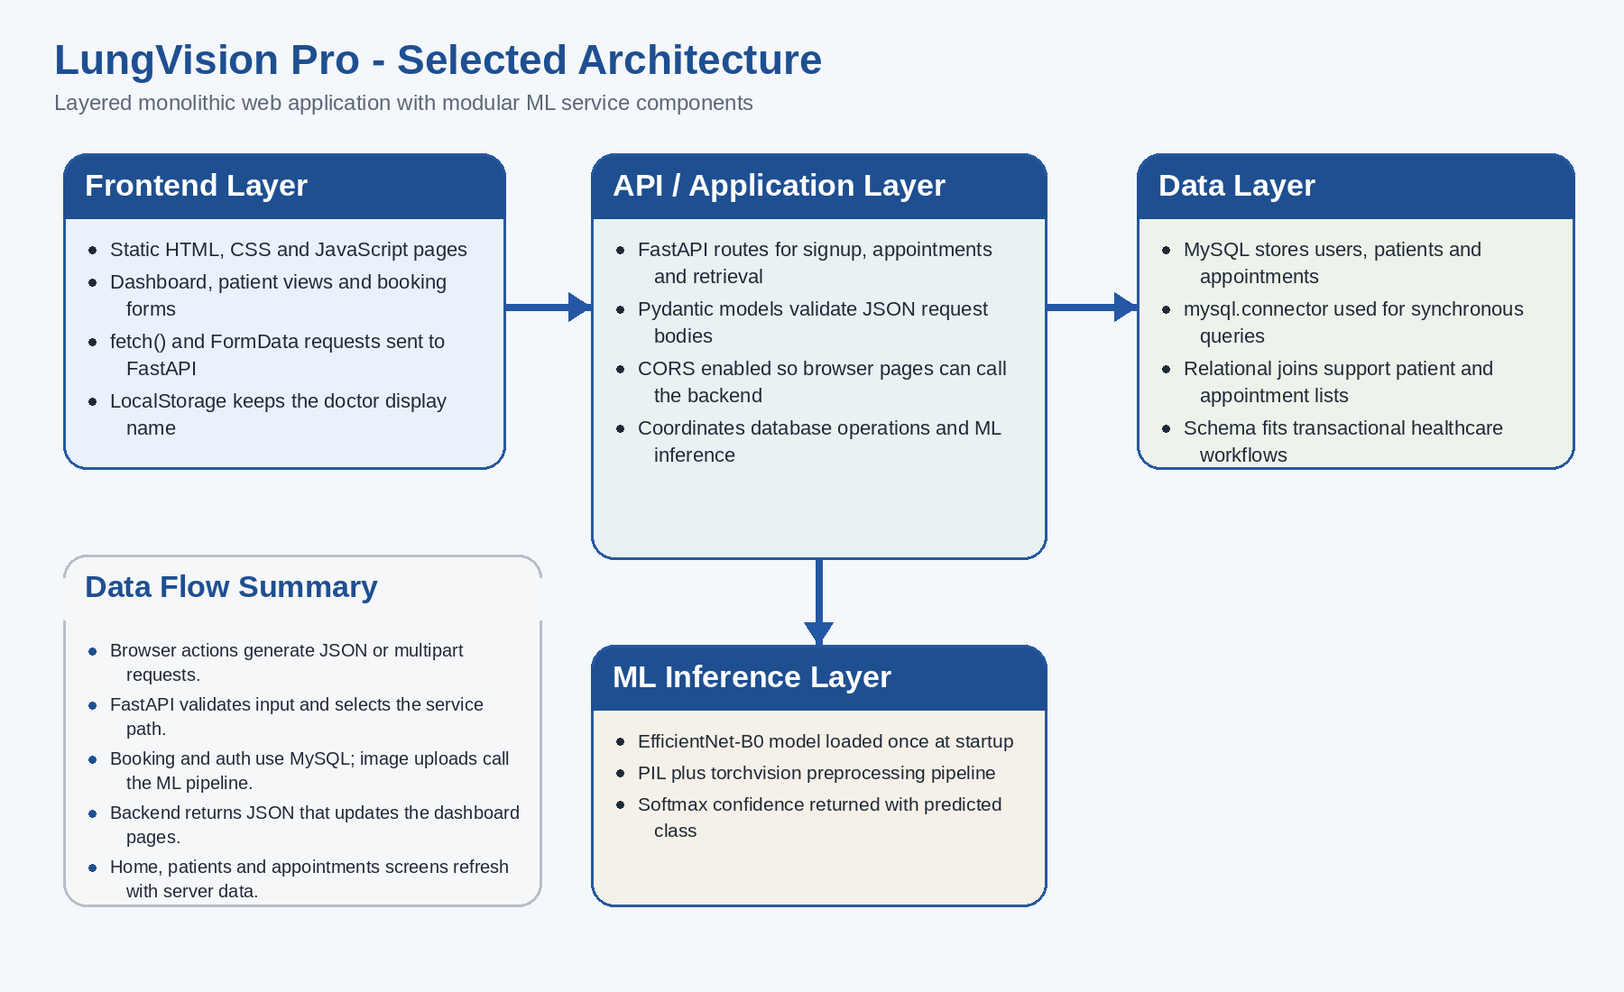
Figure 2. Selected layered-monolith architecture extracted from the code structure and runtime flow.
4. Interface Contracts
The project is integration-heavy, so interface contracts are critical. This section documents the observable API endpoints, request shapes, response expectations, and frontend-to-backend touchpoints based on the submitted code.
Endpoint | Method | Request schema | Response | Status
/ | GET | None | {"message": "Lung Cancer Detection API Running"} | Implemented
/signup | POST | full_name, email, password, dob, address | Success message after doctor creation | Implemented
/public-book-appointment | POST | email, appointment_time, reason? | Success or booking conflict error | Implemented
/create-patient | POST | first_name, last_name, dob, email, phone | Success or already exists message | Implemented
/get-appointments | GET | None | Appointment list joined with patient names | Implemented
/predict-lung-cancer | POST multipart | file: image upload | prediction label + confidence | Implemented
/login | POST | email, password | Doctor identity for localStorage | Expected by frontend, not observed
/patients | GET | None | Patient list for dropdowns and tables | Expected by frontend, not observed
/register-patient | POST | Expanded patient profile payload | Registration confirmation | Expected by frontend, not observed
/add-appointment | POST multipart | patient_id, doctor_id, appt_date, appt_time, reason | Save confirmation | Expected by frontend, not observed
Key data schemas in use:
• UserSignup schema: full_name: str, email: EmailStr, password: str, dob: str, address: str.
• PublicBooking schema: email: str, appointment_time: str, reason: Optional[str].
• PatientCreate schema: first_name: str, last_name: str, dob: str, email: str, phone: str.
• Prediction response schema: { prediction: string, confidence: float }.
Component interfaces and integration points:
• detection.js sends FormData to /predict-lung-cancer and expects prediction/confidence JSON to update the DOM.
• home.js requests /get-appointments and derives dashboard statistics in the client layer.
• appointments.js expects patient lookup data from /patients and submits multipart appointment creation to /add-appointment.
• patients.js expects a richer patient registration contract than the currently visible PatientCreate model supports.
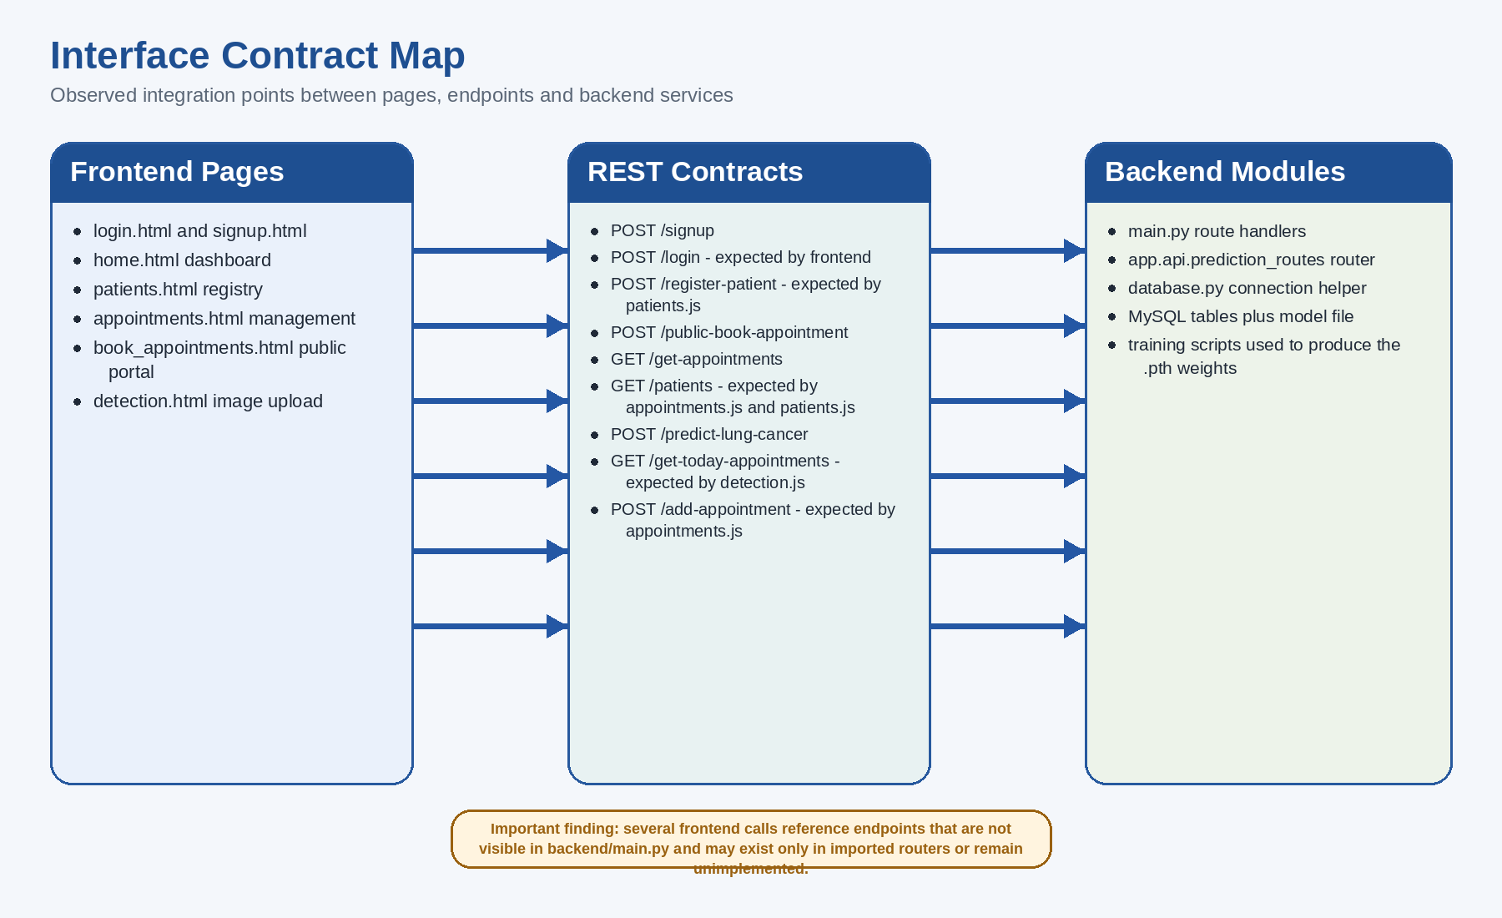8. Final Assessment and Recommended Next Steps
Figure 3. Interface map showing both implemented and expected integration points.
5. Technology Stack Justification
Technology | Why it fits this project | Alternative considered | Assessment
FastAPI | Strong typing via Pydantic, fast endpoint development, built-in docs, good fit for Python ML integration | Flask or Django | FastAPI is the strongest fit because the same language can serve both API logic and ML code
Vanilla HTML/CSS/JS | Low learning curve, fast for capstone prototyping, no bundler needed for static pages | React or Vue | Acceptable for MVP, but harder to maintain as UI complexity grows
MySQL | Relational model suits users, patients and appointments; joins are straightforward and data is transactional | MongoDB or PostgreSQL | Relational choice is correct; PostgreSQL would also be strong, but MySQL is simpler and commonly taught
PyTorch + torchvision | Excellent support for transfer learning and EfficientNet-B0; direct compatibility with training and inference scripts | TensorFlow/Keras | Good choice given model loading and preprocessing already use PyTorch
EfficientNet-B0 | Efficient transfer-learning backbone with solid accuracy-to-compute ratio for medium-size image tasks | Custom CNN or larger EfficientNet | Appropriate balance between performance and training cost
localStorage for session name | Very easy for demo flow and page personalization | JWT or secure cookie sessions | Only suitable for demonstration, not for production security
Learning curve and compatibility observations:
• React or Vue would improve component reuse and state handling, but they would also add build tooling and framework conventions that may distract from a capstone deadline.
• MySQL is compatible with the CRUD-heavy healthcare workflow. The main improvement needed is better connection management and secrets handling rather than a database swap.
• Python across training and serving is a major advantage. It avoids serialization friction and reduces the number of languages needed to keep the model in production.
6. Design Patterns Observed or Strongly Applicable
Pattern | Where it appears or should appear | Reason it matters
Layered architecture | Frontend files, FastAPI routes, database access and ML service modules are separated into distinct responsibilities | Improves maintainability and keeps UI, business logic and data access conceptually distinct
Model-Service pattern | model_loader.py and lung_prediction_service.py isolate model initialization and prediction behavior | Prevents repeated model loading and keeps inference logic reusable
MVC-style separation | HTML pages act as views, JS files act as controllers, and MySQL/Pydantic objects serve as model representations | Helps explain how user interactions are transformed into API requests and rendered results
Factory-like object creation | Pydantic models create validated request objects for endpoint handlers | Provides predictable contract validation at service boundaries
Observer/event-driven UI | DOMContentLoaded listeners and form submit handlers react to user events and API responses | Keeps browser screens synchronized with backend data
Pattern relationships:
The layered architecture is the top-level structural pattern. Inside it, MVC-style page organization explains UI behavior, while the model-service pattern isolates the ML subsystem from route handlers. Event-driven browser code acts as the glue between views and REST contracts. Together these patterns make the system understandable even though it is not yet fully formalized into a larger enterprise framework.
7. Supporting UI Evidence
The submitted screenshots confirm that the solution is designed as an operational product, not only as a backend or notebook demonstration. The UI covers dashboard analytics, appointment management, and a dedicated diagnostic page for image upload.
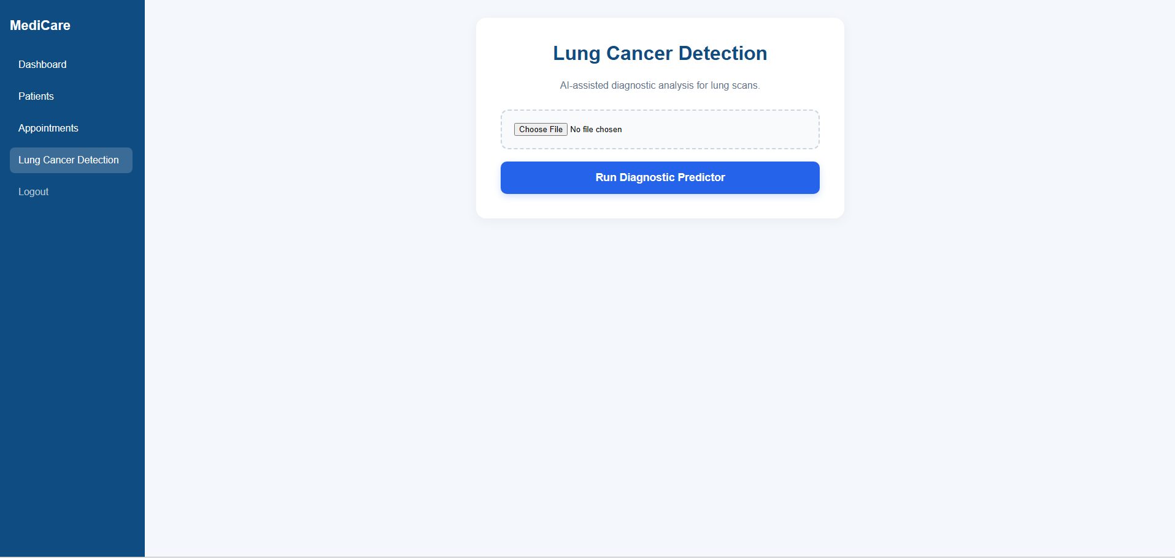
Figure 4. Diagnostic interface for uploading a scan and showing predicted class/confidence.
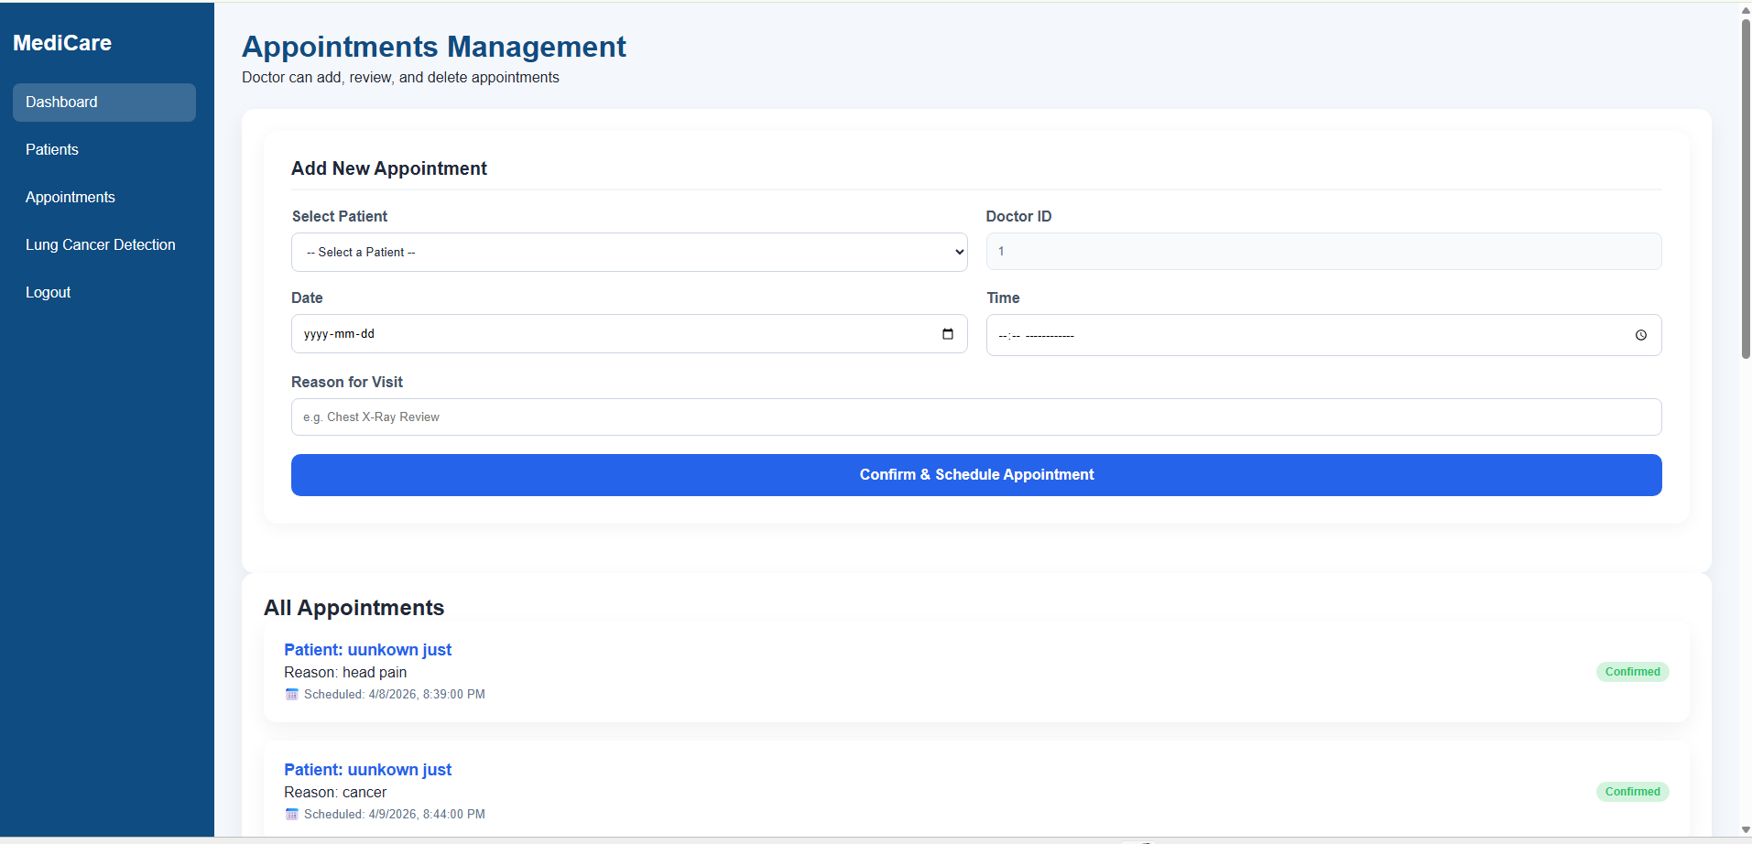
Figure 5. Appointment-management screen demonstrating workflow support beyond pure AI prediction.
Conclusion
Overall, the submitted project makes a sound architectural choice for a capstone: a layered monolithic application that keeps the machine-learning path integrated with a practical doctor’s workflow. That choice matches the project size, available team capacity, and demonstration goals. The stack is coherent, and the modular inference code is one of the strongest design decisions in the repository.
The main issue is not the high-level design but contract completion. Several frontend modules assume routes and data fields that are not visible in the inspected backend. That means the architecture is conceptually correct, but the implementation contracts still need one final alignment pass before the system can be considered fully complete.
Priority improvements before final submission or deployment:
• Unify the API contract so every frontend fetch target has a matching backend route and schema.
• Move database credentials out of source code into environment variables and use stronger password handling than plain SHA-256.
• Standardize database access to one library and add service/repository helpers for cleaner data access.
• Add explicit test cases for login, patient registration, booking collision checks and prediction endpoint error handling.
• Consider evolving the ML module into a separately scalable service only after the monolithic version is stable and validated.
In conclusion, the selected architecture is justified and appropriate. With endpoint alignment, security hardening, and modest refactoring, this capstone can be presented as a credible end-to-end healthcare software system that combines web engineering with applied deep learning.

